LAB EXERCISE:

1. Write a simple poem and represent it as a web page. Give a title for the poem.

Make rhyming words in the poem as bold.

1. Assume you have brought a new car. Write down the list of additional accessories you need for the car as an unordered list in HTML. Also, list the travel plans on the car as an ordered list.

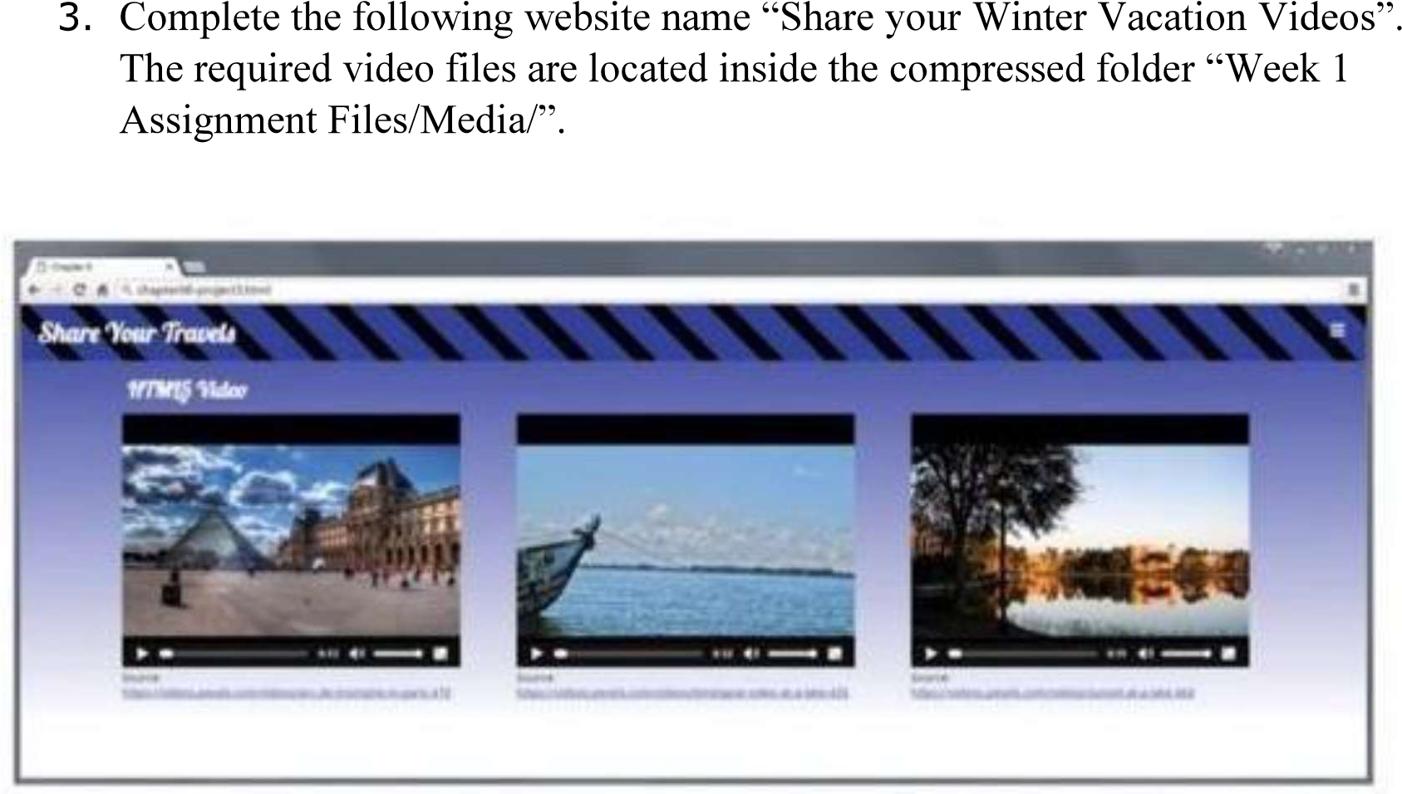

Hint: Add a <video> element to a <figure> element that will either play paris.mp4, paris.webm or paris.ogv in the element. Test in different browsers

4. Create the following output in HTML

5. Create an array of Javascript objects for the data in question 4 and display each row in the table form through Javascript code.

<head>

<meta charset="utf-8">

<title>Table</title>

<style>

table, th, td {

border: 1px solid black;

}

th {

background-color: red;

text-align: center;

}

td {

text-align: right;

}

.country {

background-color: yellow;

}

.year {

background-color: rgb(128, 158, 223);

}

.pop {

background-color: rgb(114, 204, 149);

}

</style>

</head>

<body>

<table>

<tr>

<th>Country</th>

<th colspan="2">Population (in Crores)</th>

</tr>

<tr>

<td rowspan="3" style="text-align: center;" class="country">INDIA</td>

<td class="year">1998</td>

<td class="pop">85</td>

</tr>

<tr>

<td class="year">1999</td>

<td class="pop">90</td>

</tr>

<tr>

<td class="year">2000</td>

<td class="pop">100</td>

</tr>

<tr>

<td rowspan="3" style="text-align: center;" class="country">US</td>

<td class="year">1998</td>

<td class="pop">30</td>

</tr>

<tr>

<td class="year">1999</td>

<td class="pop">35</td>

</tr>

<tr>

<td class="year">2000</td>

<td class="pop">40</td>

</tr>

<tr>

<td rowspan="3" style="text-align: center;" class="country">UK</td>

<td class="year">1998</td>

<td class="pop">25</td>

</tr>

<tr>

<td class="year">1999</td>

<td class="pop">30</td>

</tr>

<tr>

<td class="year">2000</td>

<td class="pop">35</td>

</tr>

</table>

</body>

</html>

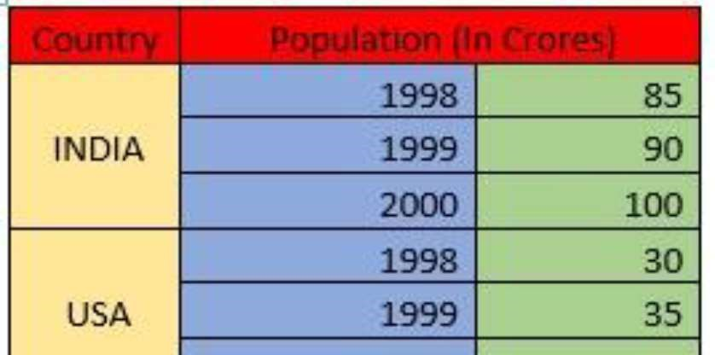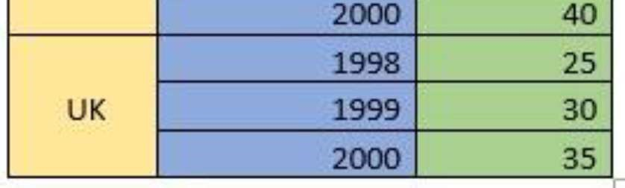

5.4